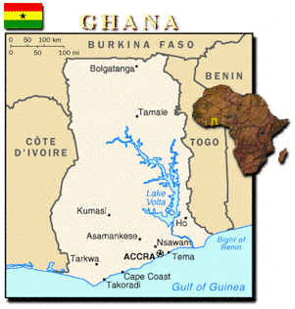  P O Box 1015 Enfield EN1 9DZ
E-Mail Address – Lamei@lakpee.com

LA KPEE -YEAR PLANNER - 2016
1.JANUARY MEETING - 9th JAN 2016
2.FEBRUARY MEETING - 6th FEB 2016
3.MARCH MEETING - 5th MAR. 2016
4.APRIL MEETING – 2nd APRIL 2016 - AGM
5.MAY MEETING – 7th MAY 2016
6.JUNE MEETING – 4th JUNE 2016
7. JULY MEETING – 2nd JULY 2016
JULY – Summer Activity
8.AUGUST MEETING – 6th AUG. 2016
9.SEPTEMBER MEETING – 3rd SEPT. 2016
24th SEPTEMBER - LA KPEE 25th Anniversary /Homowo
10.OCTOBER MEETING - 1st OCT 2016
11.NOVEMBER MEETING – 5th NOV. 2016
12. DECEMBER – XMAS PARTY 10th / 17th DEC. 2016

Charity Registration No 1151920
www.lakpee.com
07956 847 268

